Backend testing:
The following functionalities were tested via API requests made from Postman.

For production, please replace `http://localhost:8000` with ` https://placement-portal-e0cggsa9gfg6ghg5.southafricanorth-01.azurewebsites.net`
Action: Create a new student
URL: http://localhost:8000/users/register/
Request body:
{
"username": "student02",
"email": "student02@example.com",
"password": "StrongPassword02",
"role": "student",
"student_id": "stu_02",
"first_name": "Dummy First Name",
"last_name": "Dummy Last Name",
"degree": "B.Sc IT",
"year_of_study": "3"
}
Response body:
{
"user": {
"id": 5,
"username": "student02",
"email": "student02@example.com",
"first_name": "Dummy First Name",
"last_name": "Dummy Last Name",
"role": "student"
},
"token": "23c827449589519dea98a1347ce2a69e49a2815c"
}

Screenshot from Postman:
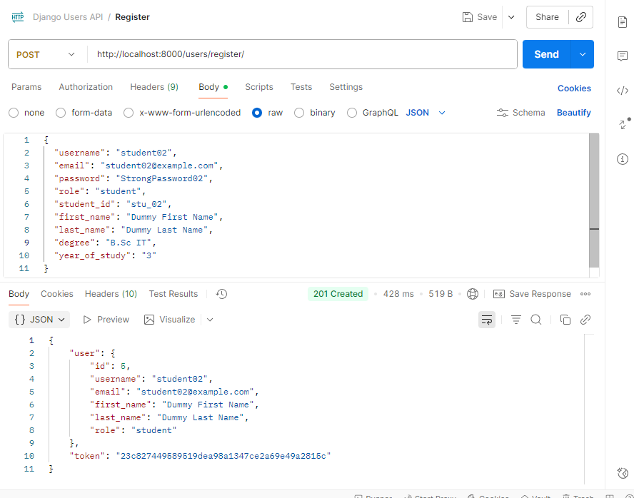
Student object saved to db and visible on admin panel:

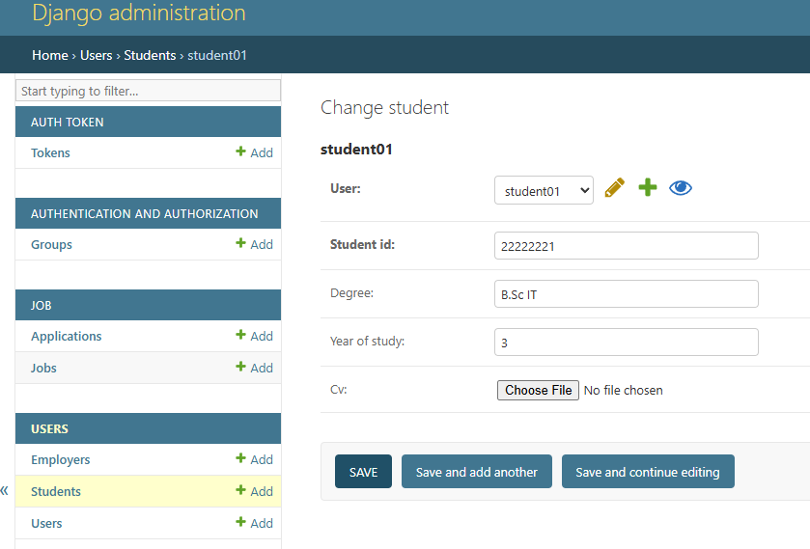
Action: Create a new employer
URL: http://localhost:8000/users/register/
Request body:
{
"username": "employer01",
"email": "employer01@example.com",
"password": "StrongPassword01",
"role": "employer",
"employer_id": "emp_03",
"company_name": "company_name",
"industry": "Organ harvesting"
}

Postman request and response:
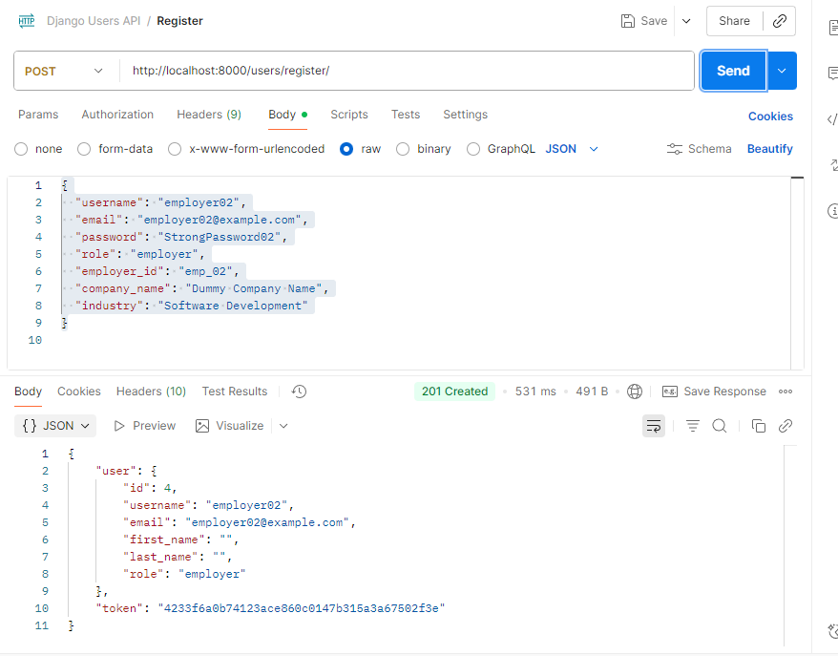

Object created, added to db and displays on Django admin panel:
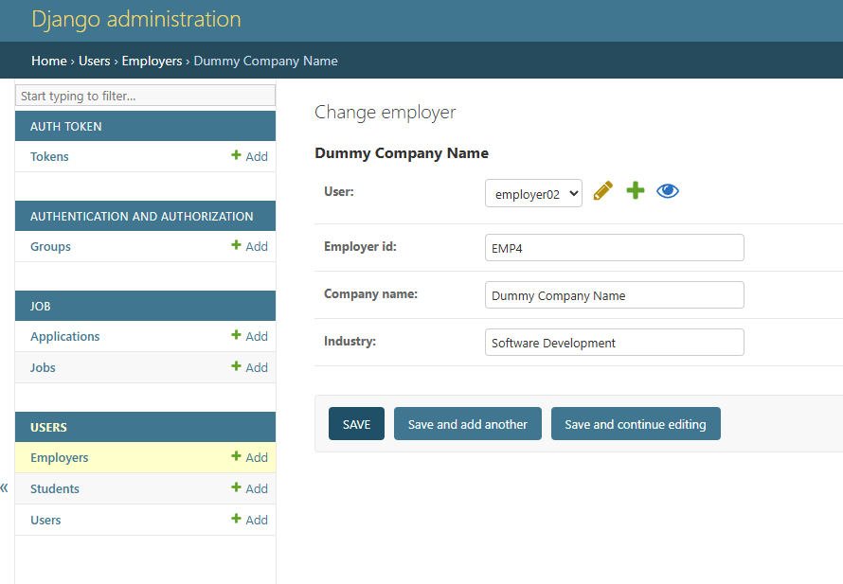

Action: Login
URL: http://localhost:8000/users/login/
Request body:
{
"username": "student02",
"password": "StrongPassword02"
}
Response body:
{
"user": {
"id": 5,
"username": "student02",
"email": "student02@example.com",
"first_name": "Dummy First Name",
"last_name": "Dummy Last Name",
"role": "student"
},
"token": "23c827449589519dea98a1347ce2a69e49a2815c"
}

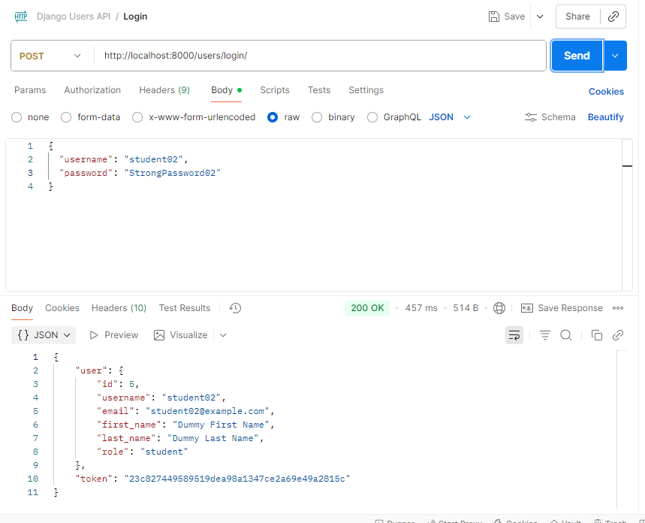

Action: Upload student cv
URL: http://localhost:8000/users/upload-cv/
The endpoint expects:
- POST /users/upload-cv/
- Authenticated user (token required)
- multipart/form-data request body
- Key name cv for the file

Screenshot from Postman:
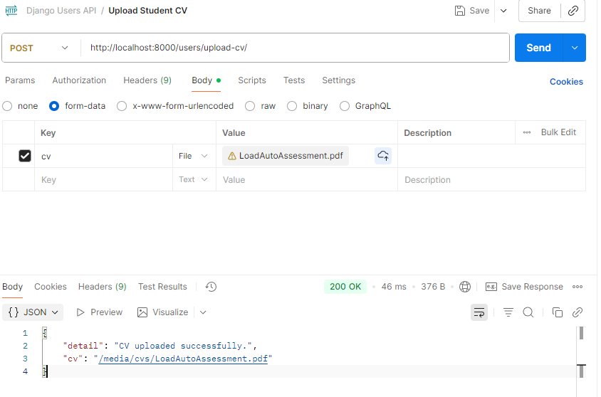

File visible on admin panel:
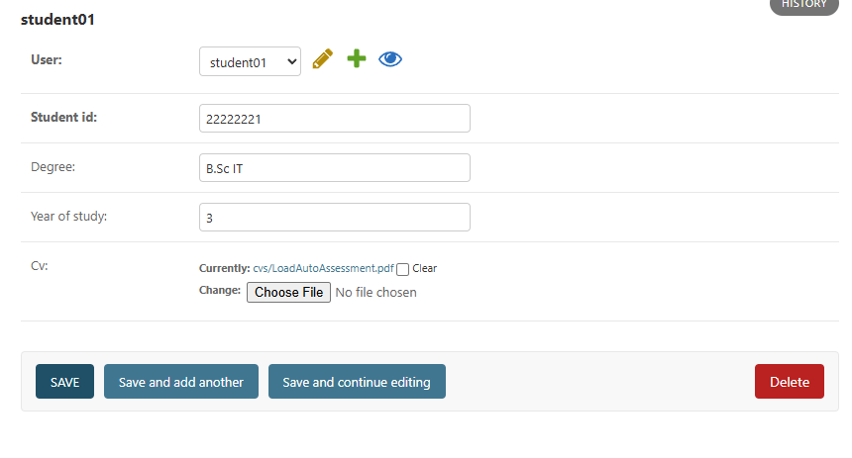

Action: Create Job/Internship
URL: http://localhost:8000/job/jobs/create/
Request body:
{
"title": "Senior Software Engineer",
"description": "A position is available for a full stack developer. Must be available after hours, be hard working, sober habits, etc.",
"type": "full time",
"experience": "8 years",
"detailed_experience": "Experience in Docker, Java, Azure is required.",
"education": "BSc in IT",
"location": "Cape Town",
"salary_range": "R800000-R900000 Per month"
}
Screenshot from Postman: 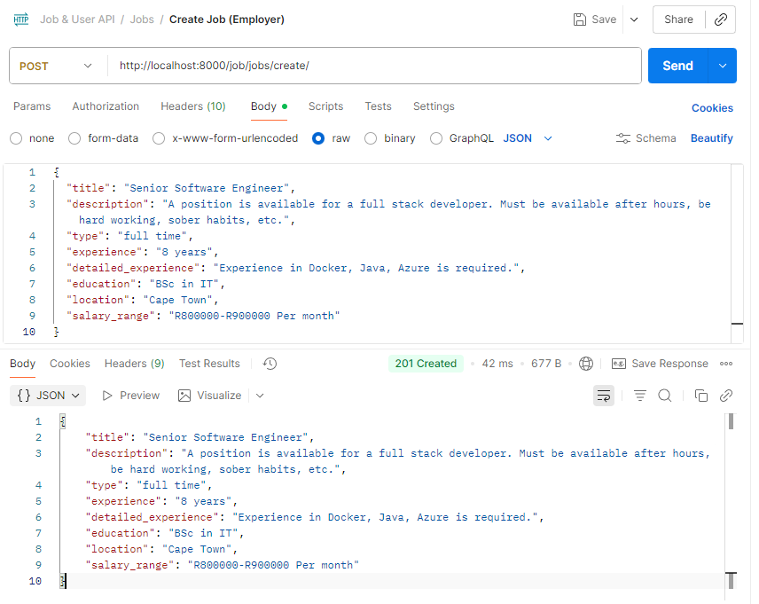
Job/Internship listing visible on admin panel:
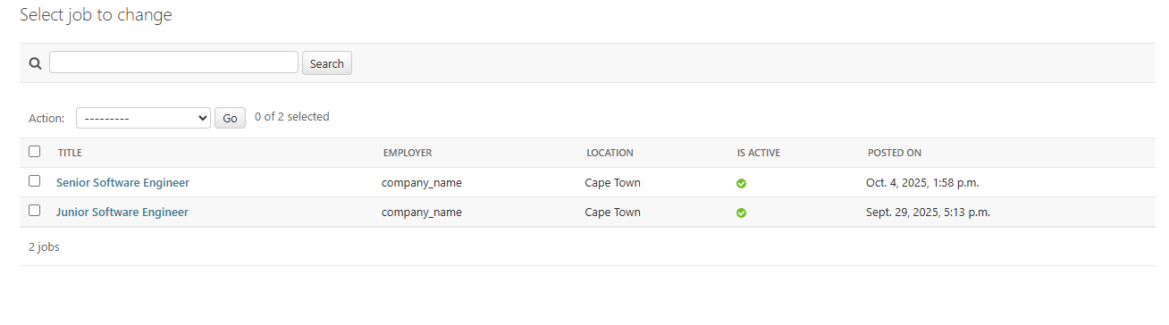

Action: List Active Jobs
URL: http://localhost:8000/job/jobs
Token needed.
Response body:
{
"count": 3,
"next": null,
"previous": null,
"results": [
{
"id": 3,
"title": "Senior Software Engineer 2",
"description": "A position is available for a full stack developer. Must be available after hours, be hard working, sober habits, etc.",
"posted_on": "2025-10-04T14:03:42.180150Z",
"type": "full time",
"experience": "8 years",
"detailed_experience": "Experience in Docker, Java, Azure is required.",
"education": "BSc in IT",
"employer": {
"id": 1,
"user": {
"id": 3,
"username": "employer01",
"email": "employer01@example.com",
"first_name": "",
"last_name": "",
"role": "employer"
},
"employer_id": "EMP3",
"company_name": "company_name",
"industry": "Organ harvesting"
},
"location": "Cape Town",
"salary_range": "R800000-R900000 Per month",
"is_active": true,
"applications_count": 0,
"user_has_applied": false
},
{
"id": 2,
"title": "Senior Software Engineer",
"description": "A position is available for a full stack developer. Must be available after hours, be hard working, sober habits, etc.",
"posted_on": "2025-10-04T13:58:00.857426Z",
"type": "full time",
"experience": "8 years",
"detailed_experience": "Experience in Docker, Java, Azure is required.",
"education": "BSc in IT",
"employer": {
"id": 1,
"user": {
"id": 3,
"username": "employer01",
"email": "employer01@example.com",
"first_name": "",
"last_name": "",
"role": "employer"
},
"employer_id": "EMP3",
"company_name": "company_name",
"industry": "Organ harvesting"
},
"location": "Cape Town",
"salary_range": "R800000-R900000 Per month",
"is_active": true,
"applications_count": 0,
"user_has_applied": false
},
{
"id": 1,
"title": "Junior Software Engineer",
"description": "A position is available for a full stack developer. Must be available after hours",
"posted_on": "2025-09-29T17:13:56.526675Z",
"type": "full time",
"experience": "2 years",
"detailed_experience": "Some elaboration on experience",
"education": "BSc in IT",
"employer": {
"id": 1,
"user": {
"id": 3,
"username": "employer01",
"email": "employer01@example.com",
"first_name": "",
"last_name": "",
"role": "employer"
},
"employer_id": "EMP3",
"company_name": "company_name",
"industry": "Organ harvesting"
},
"location": "Cape Town",
"salary_range": "R200000-R300000",
"is_active": true,
"applications_count": 0,
"user_has_applied": false
}
]
}

Action: Student applies for job:
URL: http://localhost:8000/job/applications/create/

Method: POST
Headers:
Authorization: Token your-token-here
Content-Type: multipart/form-data

Body (form-data):
job: 1 (or the valid job ID)
cover_letter: "I am interested in this role."
Screenshot from Postman:
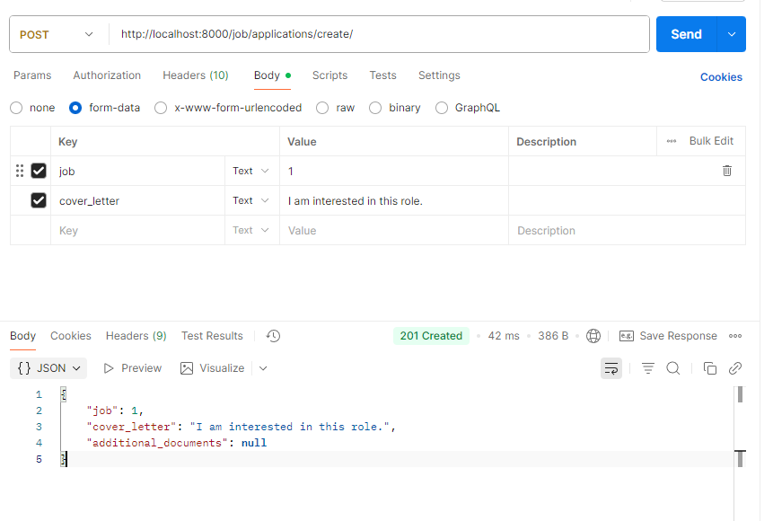

Application visible in admin panel, cv visible to employer:
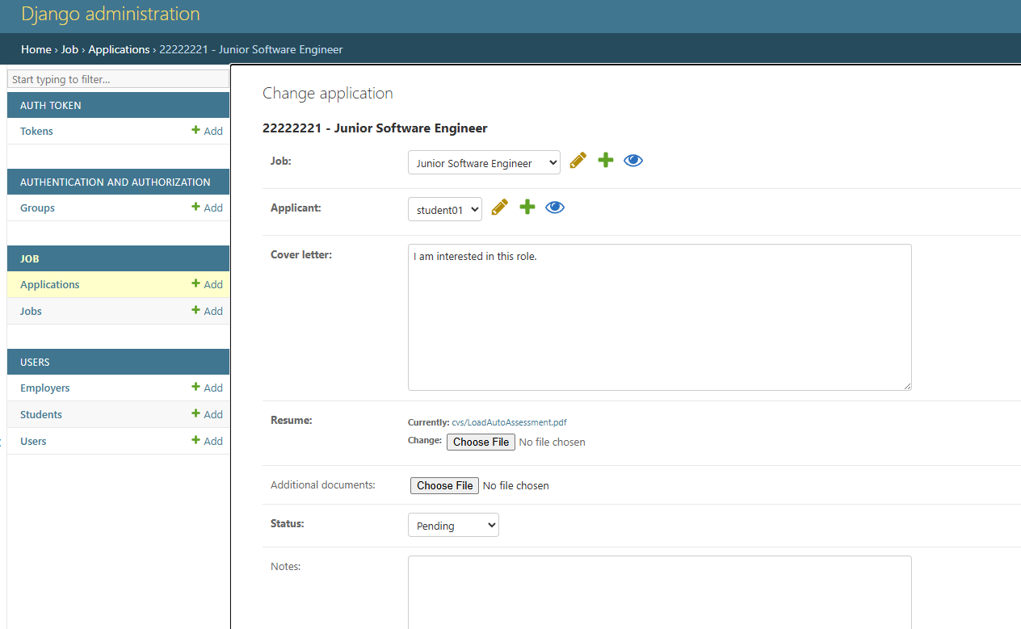

Action: Student views his/her applications:
URL: http://localhost:8000/job/applications/my

Method: GET
Headers:
Authorization: Token your-token-here
Response body:
{
"count": 1,
"next": null,
"previous": null,
"results": [
{
"id": 1,
"job": {
"id": 1,
"title": "Junior Software Engineer",
"description": "A position is available for a full stack developer. Must be available after hours",
"posted_on": "2025-09-29T17:13:56.526675Z",
"type": "full time",
"experience": "2 years",
"detailed_experience": "Some elaboration on experience",
"education": "BSc in IT",
"employer": {
"id": 1,
"user": {
"id": 3,
"username": "employer01",
"email": "employer01@example.com",
"first_name": "",
"last_name": "",
"role": "employer"
},
"employer_id": "EMP3",
"company_name": "company_name",
"industry": "Organ harvesting"
},
"location": "Cape Town",
"salary_range": "R200000-R300000",
"is_active": true,
"applications_count": 1,
"user_has_applied": true
},
"applicant": {
"id": 1,
"user": {
"id": 2,
"username": "student01",
"email": "student01@example.com",
"first_name": "Sam",
"last_name": "Samson",
"role": "student"
},
"student_id": "22222221",
"degree": "B.Sc IT",
"year_of_study": "3",
"cv": "http://localhost:8000/media/cvs/LoadAutoAssessment.pdf"
},
"cover_letter": "I am interested in this role.",
"resume": "http://localhost:8000/media/cvs/LoadAutoAssessment.pdf",
"additional_documents": null,
"applied_date": "2025-10-04T16:32:03.745092Z",
"status": "pending",
"notes": ""
}
]
}

